**Name: _______________________________________ Partner: ________________________________**

**Python Activity 6: IF-ELSE Statements**

|  |
| --- |
| **Learning Objectives**  Students will be able to:  *Content:*   * Implement the Python syntax of an if/else statement * Determine good test data for programs that include if/else statements   *Process:*   * Write code that includes if statements and if/else statements   **Prior Knowledge**   * Python concepts from Activities 1-6 |

|  |
| --- |
| **IF Statement – Python Program** |

1. What is the output of the program listed above? What would the program print if the value stored in the variable of **grade** was 90?

It’s assigning the variable grade the value of 95. The second line says if the grade was higher than 94 you get Excellent! printed as a reward. If 90 was entered nothing is printed.

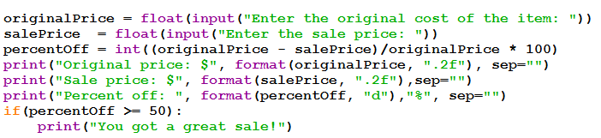2. Enter and execute the following code. Use various values for the original cost and the sale price.

Explain what the following lines of code do. Each line appears in the program above.

a. originalPrice = float(input("Enter the original cost of the item: "))

it assigned your input value to the variable originalPrice and makes the number a flaot value so that you can use decimals for cents and multiplying.

b. percentOff = int((originalPrice - salePrice)/originalPrice * 100)

this code calculates the percent off the total price and makes it an int instead of a float

c. print("Original price: $", format(originalPrice,".2f"), sep="")

it prints the original price with 2 decimal places with the no space between the dollar sign and the value

d. print("Percent off: ", format(percentOff, "d"),"%", sep="")

prints the percentage off so you know how much you got off.

e. if percentOff >= 50:

print("You got a great sale!")

**If the sale is 50% or more you get the text You got a great sale prints.**

3. Revise the program in #2. If the percent off is 50% or more print “Congratulations!” in addition to what is already printed. Use a second print statement to do this. Rewrite the code for the last part of the program that includes the **if** statement.

originalPrice = float(input("Enter the original cost of the item: "))

salePrice = float(input("Enter the sale price: "))

percentOff = int((originalPrice - salePrice)/originalPrice * 100)

print("Original price: $", format(originalPrice, ".2F"), sep="")

print("Sale price: $",format(salePrice, ".2f"),sep="")

print("Percent off: ", format(percentOff, "d"),"%", sep="")

if(percentOff >= 50) :

print("You got a great sale!"), print("Congratulations!")

4. Revise the program in #2 so that it prints “Done!” when the program is complete – no matter what the percent off is. How does the placement of this line of code differ from the placement of the code created for #3?

print("Percent off: ", format(percentOff, "d"),"%", sep="")

print("Done!")

it just goes before or after all other code just with a print command.

|  |
| --- |
| **Python Program** |
|  |

5. Enter and execute the Python program above.

a. Test the program at least three times. List the three test data you used and the corresponding output. Be sure you test each part of the condition. Explain why the data you chose were the best data to use to thoroughly test for the program.

2000 68 412

Over 212 so it would give me a boiling answer same with 412. 68 is under 212 so I knew it would give me a not boiling answer.

b. Now add another print statement to the Python program above so that it prints “That’s really hot!” when the water is 212 degrees or hotter. Rewrite the if/else below with this statement included.

temperatureString = input("Enter the water temperature in degrees Fahrenheit: ")

temperature = int(temperatureString)

if temperature >= 212:

print("Water is boiling.")

else:

print("The water is not boiling.")

if temperature >= 212:

print("Thats really hot!")

6. Suppose you want to determine if a student is ready to graduate. The three criteria for graduation are that the student has earned at least 120 credits, their major GPA is at least 2.0 and their general GPA is also at least 2.0.

Which Boolean expression would be the correct test for Python code?

a. numCredits >= 120 or majorGPA >= 2.0 or overallGPA >= 2.0

b. numCredits > 120 and majorGPA > 2.0 or overallGPA > 2.0

c. numCredits > 119 and majorGPA >= 2.0 and overallGPA >= 2.0

d. numCredits >= 120 and majorGPA >= 2.0 and overallGPA >= 2.0`

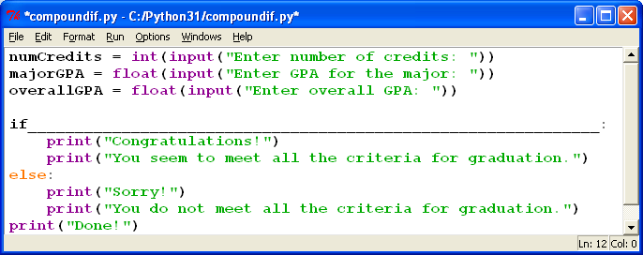

**Missing Boolean expression**

7. Enter and execute the program in #6. Include your choice for the correct Boolean expression. Create several sample data sets to test 10 different possibilities for the Boolean expression (There are 27 different combinations of possibilities). List the data you used to test these possibilities for the expression. Each set of sample data should test a different combination of possibilities.

|  |  |  |  |  |
| --- | --- | --- | --- | --- |
| **Data Set** | **numCredits** | **majorGPA** | **overallGPA** | **Expression Result (True or False)** |
| 1 | 140 | 3.5 | 3.2 | True |
| 2 | 67 | 4.0 | 4.0 | false |
| 3 | 120 | 2.0 | 1.7 | false |
| 4 | 500 | 2.2 | 2.0 | true |
| 5 | 27 | 4.0 | 3.0 | False |
| 6 | 122 | 3.0 | 3.0 | True |
| 7 | 114 | 1.1 | 0.77 | False |
| 8 | 44 | 4.0 | 2.2 | False |
| 9 | 99 | 4.0 | 2.1 | FALSE |
| 10 | 124 | 1.9 | 2.2 | False |

**Application Questions: Use the Python Interpreter to check your work**

1. Write the code for an **if** statement that adds 5 to the variable **num1** if the value stored in the variable **testA** equals 25. Otherwise subtract 5 from **num1.**

num1 = 10

testA = 25

if testA == 25:

print(num1 + 5)

else:

print(num1 - 5)

1. Write a Python program that prompts the user for a word. If the word comes between the words **apple** and **pear** alphabetically, print a message that tells the user that the word is valid, otherwise, tell the user the word is out of range.

word=input("Choose a word: ")

if "Apple" < word < "Pear":

print("Valid")

else:

print("Word our of range.")

3. Write a Python program that prompts the user for the cost of two items to be purchased. Then prompt the user for payment. If the amount entered is less than the total cost of the two items, print a message that states how much is still owed. Otherwise, print a thank you message and state how much change will be given.

price1=float(input("How much does your first item cost?: "))

price2=float(input("how much does your second item cost?: "))

totalPrice = (price1 + price2)

print("Your total will be: $", totalPrice,sep='')

paidTotal= float(input("insert some money:"))

change = paidTotal - totalPrice

owed = totalPrice - paidTotal

if paidTotal == totalPrice:

print("Thank you!")

else:

if paidTotal < totalPrice:

print("you still owe: $", format(owed, ".2f"), sep="")

else:

print("Your change is: $", format(change, ".2f"), sep="")

print("Thanks have a nice day!")

4. Write a Python program that prompts the user for a multiple of 5 between 1 and 100. Print a message telling the user whether the number they entered is valid.

number=int(input("Pick a number that is a multiple of 5 between 1 and 100: "))

if number %5==0 and 0<number<100:

print("Your number is valid.")

else:

print("Your number is invalid.")